

The Lighthouse
Zion & Trinity Lutheran Churches
950 Huron
St. Ignace, MI 49781

Address Service Requested

Nonprofit Org.
U.S. Postage
PAID
St. Ignace, MI 49781
Permit No. 55

,
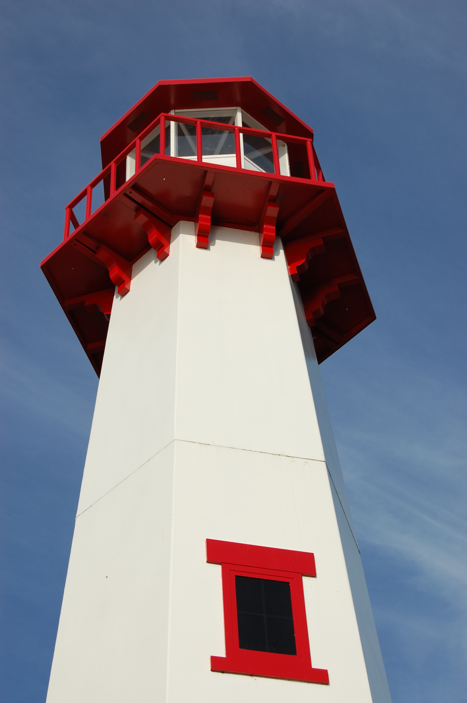
THE LIGHTHOUSE

Newsletter for July 2014

Many are asking, "Who can show us any good?" Let the light of your face shine upon us, O LORD.
Psalm 4:6

Message from Our Pastor

So I am really into the World Cup. Like really into it. I have watched every game so far. I am a busy guy so many of them I have had to record and watch later, but I have still watched them all. So if you see me working in the middle of the afternoon, don’t tell me any soccer scores. So far it has been a great World Cup. Full of goal scoring and excitement as well as some pretty huge upsets. I saw two of those the other night during the USA’s game against Portugal. Unfortunately the one missing was the huge upset. I’m still mad about that. What helps my anger though is the fact that I will still have two teams to root for even if the United States don’t make it to the next round, Germany and the Netherlands.

You see my Dad’s family is all from Germany while my mom’s is all from the Netherlands. And even though they have been living here for over a hundred years and I have never been to either of those places, I still find myself rooting for them. I guess having ties to another country is just a part of so many American’s identities. Even though we are Americans first we are also German and Dutch and Irish and Italian and Scottish and Swedish and Finnish and the list goes on and on. That connection back to the land of your ancestors and to your heritage stays strong.

Which I think really makes our identity as Christians so amazing. As Christians our identity isn’t tied to a nationality or a particular people. It spans the nations and the globe. Bringing people from all different backgrounds and heritages together. In Christ it doesn’t matter where you came from, or even where you currently live. In Christ we are united despite our differences. In Christ all people in all places are simply God’s Children. Our borders, our languages, our politics, and our fighting no longer matter. We are all brothers and sisters in Christ. We all root for each other. We all help, support, and love each other. And hopefully someday soon, in Christ all nations of this world will finally learn to truly live together in that peace and love that only Christ can bring. Now that is a goal worth celebrating.

Newsletter

The Newsletter was not adopted.

Noisy Offering

The noisy offering for July will go for Fortune Lake Camp

Church History Study

Where did the church start and how did we get it to where we are today? This is an important question that unfortunately too many Christians cannot answer. If you no longer want to be one of those Christians, come and learn all about the important and fascinating history of our Church.

Church History will continue to be studied at Trinity on Fridays at 1 pm and at Zion on Thursdays at 7 pm.

Vacation Bible School

In August we will be having Vacation Bible School at the United Methodist Church. We will need lots of help to have a successful program at lots of different capacities. So, if you are interested please talk with Pastor Jeremy as soon as possible.

GIFT

This fall we are planning to kick off a new education program at the church for all ages. It is called G.I.F.T, or Growing In Faith Together. This is a inter-generational experience where all gather together to learn the Bible story and discuss how it affects their life and their faith. All opinions and voices are welcome regardless of age or knowledge of the subject matter. We teach each other as we learn from each other. This summer though we will begin to get a taste for what this can look like. So I invite you to come to church for our pre-worship fellowship where you will have the opportunity to talk about some faith issues. We will be using the questions in the back of your bulletins as a guide for discussion. I encourage everyone to come and at least see what it is all about.

Outdoor Worship

We will be having joint worship services with the United Methodist Church at the Red, White, and Blue Park on Saturdays starting at 7:00 PM. This will be a wonderful opportunity to enjoy the beauty of the area while worshiping its creator. Bring a lawn chair and come worship with us.



The American Cancer Society’s Relay for Life will be held Friday, August 9th, 11 a.m. to 11 p.m. at the St. Ignace Middle School. If you are interested in becoming a team member, purchasing a luminary or walking during the Relay, please call Sandy Feleppa on her cell 430-8010.

Trinity Worship Families

July 6 Rose Family
July 13 Movalson Family
July 20 Gustafson Family
July 27 Smith Family

Zion Funeral Committee August-November

Team Leader: Linda Wilkins (643-7710)
Co-leader: Rita LaVake (906) 298-0005

Servants for Zion

Ushers & Greeters

July 6 Casey & Angie Brake
July 13 Tom Schenkel & Max Coburn
July 20 Mark & Carol Elmblad
July 27 Paul & Tammy Shepard

Lectors

July 6
July 13
July 20
July 27

Communion Assistants

July 6
July 13
July 20
July 27

Acolytes

July 6
July 13
July 20
July 27

Altar: Lorraine Graham
Money Counters: Lana Lennington and Lorraine Graham

Baptismal Anniversaries

July 3 Brian Olsen
July 7 Emma Feleppa
July 16 Alicia LaLonde
July 16 Rebecca LaLonde
July 17 Lilyan Stenson
July 21 Brenda St. Onge
July 21 Loni LaJoice
July 27 Eunice Therrian
July 29 Kristine McDonald

Birthdays in July

July 1 Max Coburn
July 4 Louise Anderson
July 7 Tracy Movalson
July 7 Joe Schlehuber
July 8 Cody Blair
July 8 Adam Chambers
July 9 Fred Feleppa
July 13 Jane Chambers
July 13 Christian Stenson
July 15 Jake Dodds
July 15 Patsy Nowak
July 15 Sharon Smith
July 16 Donna Harju
July 16 Lilyan Stenson
July 17 Candy DeKeyser
July 17 Page Paul
July 17 Sara Sorenson
July 24 Aiden Stenson
July 24 Kaiden Stenson
July 27 Cindy Hendricks
July 28 Richard Galor
July 28 Wendy McCluskey
July 30 Mary Belonga
Council Meetings

Trinity Council Meeting – 6 pm, July 21st
Zion Council Meeting – 6:30 pm, July 16th

Zion’s Council Members

President: Faith Gaubault 298-1800
Vice-President Paul Shepard 984-2069
Secretary: Lorraine Graham 643-8419
Co-Treasurers: Dawn Akers 643-7552
Lana Lennington 643-6576
Nicole Garen 643-8387
Tim Idalski 643-6574
Fred Feleppa 643-6793

Trinity’s Council Members

President: Jerri Rose 292-5570
Vice-President Tracy Movalson 292-5581
Secretary: Sharon Chalmers 292-5440
Treasurer: Pega Kennedy 292-5633
Co-Treasurer: Jim Rose 292-5570
Financial Secretary: Joe Chalmers 292-5433
WELCA: Pega Kennedy 292-5633
John Kennedy 292-5633
Jim Dyer 292-5433
Lois Movalson 292-5581

Treasurer's Report for Zion
January 1, 2014 through June 12, 2014
Income:
 | Building | $1,908.00
 | General | $27,695.08
 | Thrivent Financial | $215.00
 | Trinity Share | $6,410.00
 | TOTAL |  | $36,228.08
Expenses:
 | Administration | $1,866.00
 | Benevolence | $2,620.00
 | Church Maintenance | $8,477.92
 | Education | $599.54
 | Parsonage Maintenance | $1,346.22
 | Pastoral | $20,711.18
 | Worship | $1,702.66
 | --To Building Fund | $1,999.00
 | --To LCF Loan | $500.00
 |  |  | $39,822.52
Balance: |  |  | $ (3,594.44)
***********************************************************
5/10/2014
General fund owes Building fund: |  |  | $ 85.00
General fund owes Mission Endowment fund: |  |  | $ 9,495.00
General Fund balance: |  |  | $ 1,285.11
Building Fund balance: |  |  | $ 11,240.49
Thrivent Investment Management Fund: |  |  | $ 329.47
WELCA Kitchen Fund: |  |  | $ 9,388.67
2011 -2014 Capital Campaign Donations |  |  | $ 21,425.00

Zion Lutheran Council Meeting
July 16, 2014
(Not enough present for a quorum on 18th, rescheduled for after church on 22nd)

Present: Pastor Jeremy, Paul Shepard, Fred Feleppa, Lana Lennington and Lorraine Graham

Pastor Report:

We will be joining with the Methodists in having Vacation Bible School at the Methodist Church for the 2nd week of August. There was discussion on if it would be better in the afternoon or evening.

Starting in mid-July we will be having evening outdoor worships at the red, white and blue park, also sharing the duties with the Methodist Church. There was discussion on whether it would be better on Saturday or Wednesday nights.

Church History will continue through July.

Service Sunday for June 29th will be trash pick-up at the red, white and blue park.

Pastor will be gone on Sunday July 6th. Orv Kabbat will lead the worship.

Treasurer’s Report was passed out.
Old Business: After a discussion, it was voted to re-designate the left-over kitchen funds toward the church roof.

After a discussion, we voted to go with Marshall’s to fix the roof.

New Business: Lana mentioned that Relay for Life was going to start at LaSalle High School on August 9th from 11 a.m. until 11 p.m.

Respectfully submitted,
Lorraine Graham

Prayer List

( If you would like someone added to the prayer list, please fill out a yellow card or call the church)


Bonnie Bergeron, Ann & Jim Dyer, Carl & Mary Belonga, Ruth Cope, LaTaunya Paquin, Christine Movalson Shaw, Lois Movalson, Phil Richel, Joy Olsen Marolf, Jim Scott, Bob Pearson, Susan Stelzer, Rob Podlesak, Judy Childs, Jackie Kallstrom, Janice Werkheiser, Judy Schlehuber Bridges, Terry Jacobson, Sandy White, Beverly Kammers, Terry Howard, Doris McFarland, Ray Burton, Janet Kanitz, Frank Feher, Phil Schaeffer, Charlie Lamoreaux, Darlene Therrian, Mary Dell, Hallie Marshall and the friends and family of Pam Movalson

Contact Information

Pastor Jeremy Winter may be reached at 906-643-0391 or at jwinter001@gmail.com or in case of emergencies,
Pastor’s cell phone number is 712-389-2747
Church telephone: 906-643-7870 - Answering machine
The secretary will be in the office on Tuesdays and Thursdays.
To email the church is: ziontrinity950@yahoo.com
The new website is at http://zionstignace.com/home.html
- Find us on facebook at www.facebook.com/zionstignace

